Electrical and Computer Engineering Capstone Project Proposal

Version 1.1

2/11/2015

**Erebus Labs**

**Open Sensor Platform**

Submitted By:

**Colten Nye**

**Steve Peirce**

**Golriz Sedaghat**

Supervisor:

**Dr. Lisa Zurk**

Sponsors:

**Dr. Mike Borowczak**

**Dr. Andrea Burrows**

**Table of Contents**

1. **Introduction……………………………………………………………..3**
2. **Project Statement……...………………………………………………..3**
   1. Background**………...……………………………………………..3**
   2. Detailed Project Description**………………………………….…..4**
3. **Methodology……………………………………………………………. 5**
4. **Project Schedule………………………..…………………………….....7**
5. **Budget……………………………………………...………………...…..8**
6. **References……………………………………………………………….9**
7. **Revision History…………………………..…………………………….10**

**1 INTRODUCTION**

An understanding of science and technology is necessary for anyone who wishes to make informed choices about issues in todays’ society. Recently there has been a significant focus on beginning technical education in Science, Technology, Engineering and Mathematics (STEM) at an earlier age. Efforts have been made to promote interests in STEM related fields among the students and encourage them in considering an STEM career in the future as well as providing the necessary background skills.

This document proposes the design and implementation of an open-source sensor platform; allowing a target audience of K-12 students and their teachers to collect and analyze data. This is accomplished by either employing the supported sensors associated with the platform or connecting their own sensor modules via an open-sourced interface specification should the desired sensors not yet be supported. Once collected, students are able to process the data and/or reprogram the device through a browser-based interface which is platform independent.

**2 PROJECT STATEMENT**

2.1 Background

The focus of Erebus Labs & Consulting LLC is on the development of Secure Hardware/Software solutions; and furthermore, Educational Outreach and STEM integration in K20 classrooms. In this respect, one of the concerns has been regarding K-12 students using sensor platform which often require programming/electronics experience which is an impediment to the use of such devices. Beyond of which there are virtually no affordable approaches to the sensor designs available for K12 students and their respective classroom budgets.

There has been previous related work done in the field by a Portland State University capstone team last year, 2013-14, which would be considered as a first revision proof of concept for this design. However, the implementation was highly complex and required experience in not only circuit and software design, but also the Linux operating system. Many students and teachers alike lack these prerequisite skills, therefore defeating the very purpose of the project in a usability sense.

2.2 Detailed Problem Description

The purpose of this project is to build an open-source sensor platform consisting of a main board and sensor break-out boards.These break-out boards simply expose the interface to communicate with the main board via a two-wire, (I2C compltible) or ADC connection. The focus is on the simple usability of the device by K-12 students and other non-technical audiences. The possible initial candidates for supported sensors are VOC (volatile organic compound), ambient light, accelerometer and temperature. This sensor array would allow the students to collect the raw data from their environment and analyze them through a browser-based, graphical interface, independent of their respective operating system. Further requirements include: low power consumption, (maximum of 3 month duty cycle) and cost, (maximum of $50 per unit) which would make the system both efficient and affordable.

**3 METHODOLOGY**

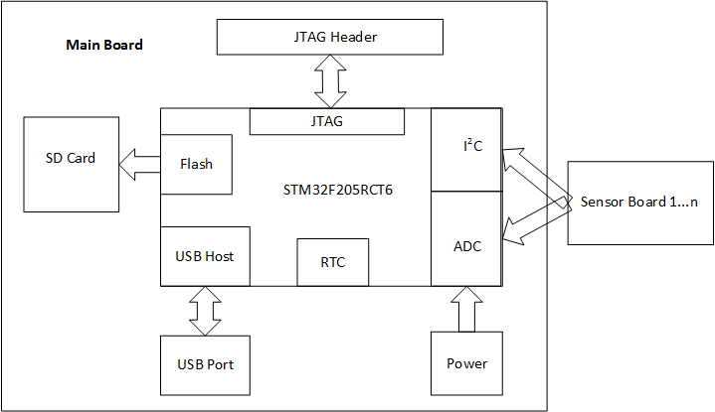

Figure 1.1 – High Level System Design

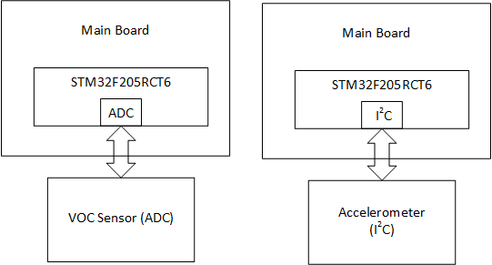

Figure 1.2 - Sensor Connections

Figure 1.1, demonstrates a high level overview of the system. One of the main considerations in the design would be the sensor and main board interface. The system should be able to identify and support different types of communication via I2C or analog input via ADC. The main board contains a microcontroller which communicates with the sensor boards, reading the collected data from the sensors on a predetermined interval, via the browser configuration tool.

Sampled data is logged to an SD Card for safe storage after power-loss or in case of a physically damaging event. Sensor boards are designed to be “stackable” for I2C devices as they are uniquely addressable as per I2C specification. Should the user choose to employ multiple of the same sensor, a 3-bit DIP switch is provided on the I2C sensor board to set the appropriate address. If the respective IC supports this feature it would allow up to sixteen (16) uniquely addressable I2C devices to be connected via two (2) buses.

The ADC channels have a predetermined “snap-in” connector type thereby limiting the possibility of damage due to incorrect installation, the initial revision will support at least 3 ADC sensors. Another possible source of revenue is the production and sale of the “breakout” boards either by Erebus-labs or a licensed third-party.

The MCU for this revision is the STM32F205X by STMicro. The processor includes multiple capabilities useful for this application including multiple I2C, USB, and SPI buses, low power consumption, on-board SDIO support, DMA, and the STMCube software platform for configuring initialization code as well as adhering to the Cortex Microcontroller Software Interface Standard (CMSIS) industry standard. Being a more “powerful” processor, the MCU also allows for feature expansion as future revisions of the project ensue.

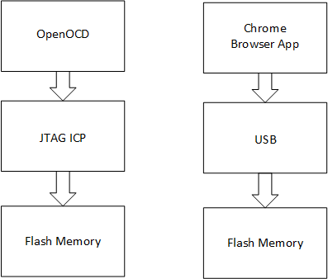

1. (b)

Figure 2 – (a) Main board design process, (b) User interface design process

Figure 2(a) shows how the STM32F2X is programmed and debugged using JTAG ICP interface through CooCox CoIDE, OpenOCD or Keil uVision development environments. Although the sensor platform is an open source design, the choice of development tools are not all free of charge. It is up to the user what they would like to invest in more elaborate development suites. This programming is is done “in-house,” verified prior to shipment and referred to as “In Circuit Programming.” It must be done at least once and requires additional equipment to do effectively, such as the Olimex ARM-USB-OCD-H ($70) or Keil ULINK Pro ($400+) JTAG units. This bootloader firmware allows the HID connection over USB to support the browser-based editing. However, a more advanced user is still able to customize the bootloader using a JTAG unit, but there is no need for the user to modify the bootloader while using the platform. This design allows the user to interact with the system and program the sensor types, intervals and values independent of the operating system through the browser application provided, (without charge) in the Google Play Store. Figure 2(b) demonstrates the user interface design of the Sensor Platform; user is able to connect to the system via USB, and program the sensor values through a Chrome based web browser application, via STM’s supported “In Application Programming,” hereafter referred to as IAP. Furthermore, user is able to save the collected data on a flash memory to prevent data loss, as well as extract the collected data for further analysis.

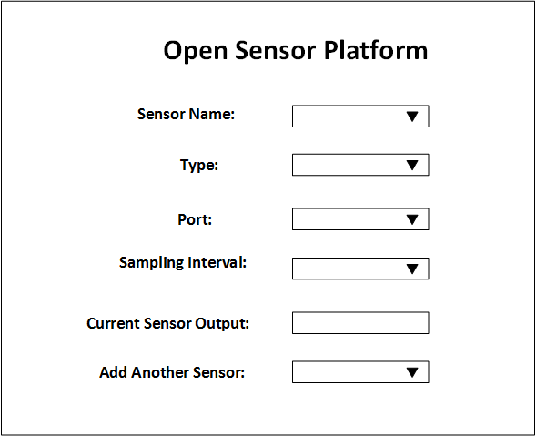

Figure 3 – Sensor Platform Chrome browser app template

**4 PROJECT SCHEDULE**

Table 1 lists the summary of the key tasks and key dates from beginning to the end of the project, which would help the team stay on track and determine whether or not the project is on schedule.

|  |  |  |  |
| --- | --- | --- | --- |
| **Task Name** | **Duration** | **Begin Date** | **End Date** |
| Proposal |  | 1/12/15 |  |
| Functional Decomposition of System |  | 1/31/15 |  |
| Identify Components |  | 1/31/15 |  |
| Final Schematic |  | 2/15/15 |  |
| Final PCB layout |  | 3/1/15 |  |
| Boards Fabbed |  | 3/8/15 |  |
| Integration |  | 3/29/15 |  |
| Testing, debugging and Fixing |  | 4/1/15 |  |
| Release |  | 5/6/15 |  |

Table 1 – Project milestone

**5 BUDGET**

Table 2 provides a summarized list of part numbers and descriptions, vendors, quantity and list prices for all system mainboard components, (not including sensors).

|  |  |  |  |  |  |
| --- | --- | --- | --- | --- | --- |
| **Item** | **Supplier** | **Part #** | **Quantity** | **Unit Price (USD)** | **Total**  **(USD)** |
| VOC Sensor | AliExpress | TGS2602 | 5 | 5.95 | 29.72 |
| Ambient Light Sensor | Mouser | BH1721FVC-TR | 5 | 2.96 | 14.80 |
| Accelerometer | SparkFun | MMA8452Q | 5 | 9.95 | 49.75 |
| Processor | Mouser | STM32F205RCT6 | 5 | 9.01 | 45.05 |
| SD Card Slot | Newark | SDBMF-00915B0T2 | 5 | 3.07 | 15.35 |
| USB Connector | Mouser | ZX62R-B-5P | 5 | 1.27 | 6.35 |
| Voltage Reg. | Mouser | LLM2936MP-3.3/NOPB | 5 | 1.78 | 8.90 |
| PCB | OSHPARK | N/A | 5 | 15.00* | 80.00 |
| **Total: 48.99 249.92** | | | | | |

Table 2 – Bill of Material

*Final quote will be provided by OshPark

**6 REFERENCES**

[1] Hemmo, Vale. *Encouraging Student Interest in Science and Technology Studies*. Paris: OECD, 2008. Print.

[2] http://www.st.com/web/en/resource/technical/document/datasheet/CD00237391.pdf

**7 REVISION HISTORY**

|  |  |  |
| --- | --- | --- |
| **Version #** | **Revision Date** | **Comments** |
| V1.1 | 1/14/2015 | Changes were made in Detailed Problem Description and Methodology, also figure 1 has been modified and figures 2 and 3 has been added |
|  |  |  |
|  |  |  |
|  |  |  |
|  |  |  |